### Material UI

#### Objectives and Outcomes

In this exercise we learn to use the Material UI (MUI) to configure and set up your template in a React application for the route index (path =’/’). At the end of this exercise, you will be able to:

* Install and configure your application to use Material UI.
* Rebuild your React application using Material UI for your template at index route.

#### Installing and Configuring React Router

* First install Material UI into your project by typing the following at the prompt:

npm install materialize-css

npm install react-materialize --force

* Import to Index.js as follow:

import M from 'materialize-css'

import 'materialize-css/dist/css/materialize.min.css'

#### Style your Navigation component

* Design by yourself in file Navigation.js using React Materialize components (Navbar and Icon), the screen display as a reference:

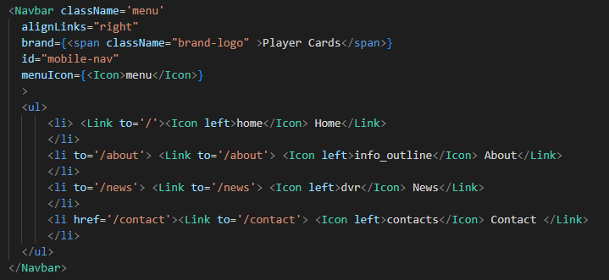



#### Style your Players component

* Design by yourself in file Players.js using React Materialize components, the number of players in a row can be option by yourself. The screen display as a reference:
* Example codes:

import { Icon, CardTitle, Row, Col, Card, Container } from 'react-materialize'

<Container>

<Row>

Data.map(=>(<Col><Card></Card></Col>))

</Row>

</Container>

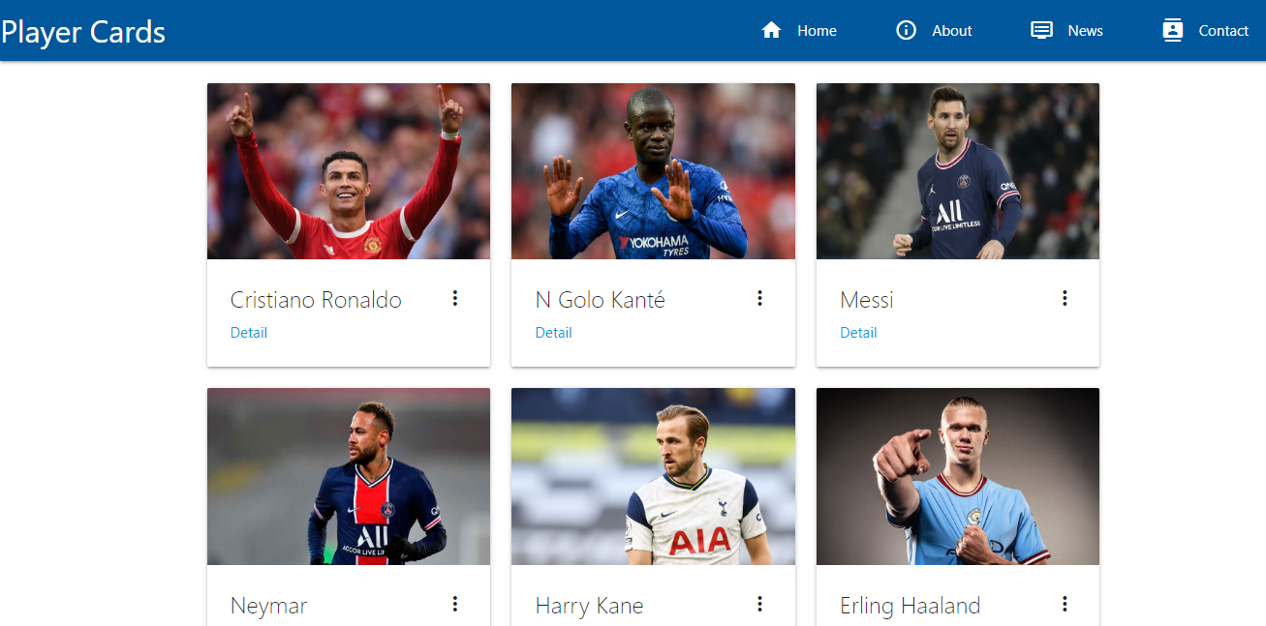

#### Conclusions

In this exercise you learn about installing, configuring and using the React Materialize components (Navbar, NavItem, Icon, Container, Row, Col, Card, CardTitle, Icon) for your React app.